Case statement

1) Write a menu driven program for mathematical calculation

a. It should take user inputs a and b

b. It should ask for mathematical operator (+, -, / and \*).

c. Do the calculation

d. Print the output

casestat.sh

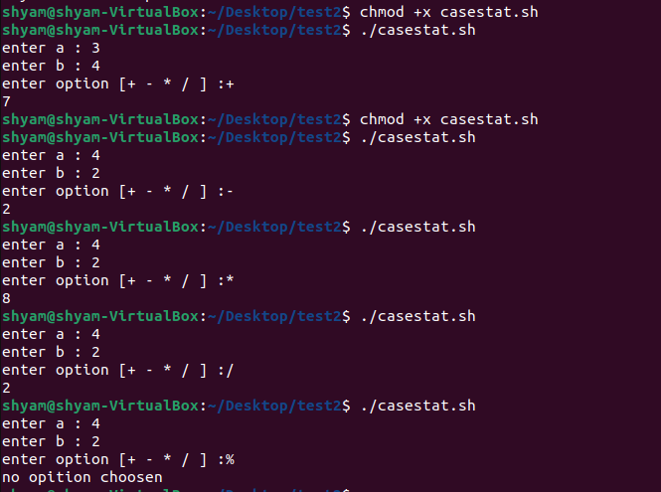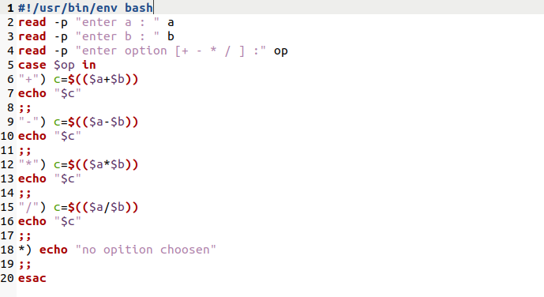

Terminal